Internet Systems Programming Progress Report

Members: Nick, Ini, Amid

In this project we sat down to decide what we want to create as a team we concluded on working on a 4 tier web app generator, that lets its user to choose his/her own theme and apply it on a full, but flexible, technology stack in just a few minutes, greatly improving development time from visual design to application deployment.

We used Github as a way to share our files together, that way when one person was done with his section and pasted we had another person in charge of compiling it.

Starting from our html we created a table in the same format of our Project assignment 2 where we did a kind of Website generator. We let our user see the elements which were drag and drop and which were not. Nicholas Riechlin took care of the JavaScript and PHP forms in this project, each function was shown in the table displayed in our Webpage, each with a definition of how to use them. It was implemented using Visual Studio code, he also implemented the use of drag and drop by creating a separate drag and drop java script file that made our webpage more user-friendly, giving our users more leeway in creating their web application. The php file was used to contact the database he created.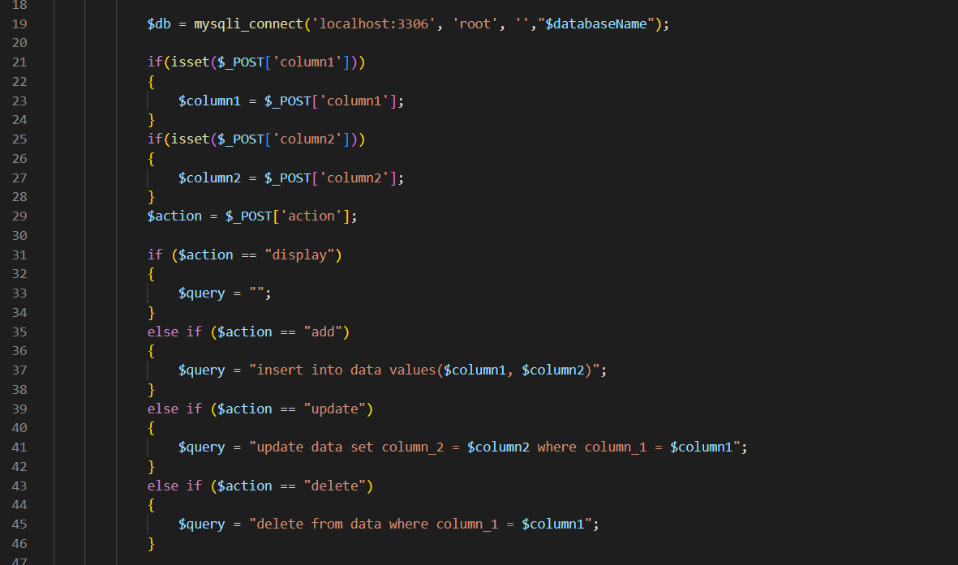

This is a section of his code that interacts with the database using if, else and else if statements to insert, extract, output and update the database. Inioluwa Adedeji, oversaw HTML creation, creating the tables and linking it to each javascript, the web frontier design was also done by him and he created the help webpage that gives assistance to the users in case they are having troubles with it. Below is a part of the HTML code created.

Amid oversaw parsing the file with user data, created by our website. He created the file that collated all the user data that was inputted by the user and stored it in a database. H